Your University at your side

Mental Health and Wellbeing at the University of Wolverhampton:
Working in groups
Tips on how to get the best from your group

- provide free and confidential individual counselling
Working in groups
- offer non-judgemental support and understanding
- are professionally trained
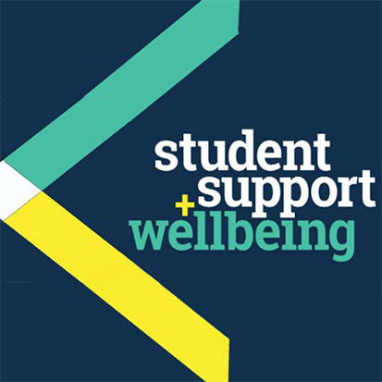
- are experienced in dealing with a wide range of problems

Counselling can:
- help you to develop your strengths
- offer you the chance to focus on and understand your difficulties
- enable you to make positive decisions and changes
- help you to develop the skills and resources to cope
- help prevent small problems from becoming bigge.r

Get in touch
You can make an appointment to see a counsellor by filling out the Contact Us form at www.wlv.ac.uk/SSW, alternatively, you can come along to one of our drop-in services. For more information go to the web address above and click on the Mental Health and Wellbeing option. From here you will find a wealth of useful information and self-help tools as well as our Drop-ins and Group activities.

University Mental Health & Wellbeing

Introduction
Team working is high on every employer’s list of essential graduate skills. University group work is central to degree- level work, helping students enhance key team-working skills such as listening, rapport-building, giving and receiving feedback, negotiation, and many more.

What problems arise with groups?
Working with others can be fun, rewarding and intellectually stimulating. It can also, however, be frustrating, upsetting and difficult. Problems arise both in individual behaviour and in group processes.

Problems with individual behaviour include:
- being over-talkative and domineering
- being passive and silent
- ‘slacking’ and relying on others to carry the load.

Problems with group functioning include:
- bad organisation and/or communication
- individuals not feeling responsible for group work
- character clashes.

Solutions to group working Problems with individual behaviour
Leaving a group member’s difficult behaviour unaddressed
over time means resentment and unhappiness can build in the group.
Hard though it may seem, being open and honest with the individual causing difficulties is essential for group repair. When handled sensitively, good results can occur.
Seek to understand the person’s behaviour. Perhaps ask some questions. This may help the person to see how they come across to others, but also may allow you to understand what ‘makes them tick’.
If this does not help, explaining how the particular behaviour is affecting the overall group process is the next step, eg. “When you take up most of the meeting time, although you have some great ideas, I sense that it shuts the rest of the group out”.

Problems with overall group functioning
Many groups fail due to lack of organisation. This can be resolved by having a ‘team charter’. This document can be altered during the course of the project, but should be drafted at the beginning, covering certain items, such as:
- when and where meetings will be held
- contact details
- essential goals of the group
- agreed division of labour
- expectations, such as what grade each person is aiming for
- deadlines
- meetings – who will facilitate, take minutes, etc.
- how to voice concerns
- an agreed plan for when ‘rules’ are broken, eg. if someone does not turn up for two meetings in a row.
Having such pre-agreed guidelines is helpful if things start to go wrong. The group document can then be consulted to help the group get back on track.
There is a risk in group work that the group as a whole will avoid its responsibilities. Often in groups people do not feel as personally responsible for the outcome as they do in individual assignments, so it may be tempting to avoid group work, especially if it is intellectually challenging or overwhelming.
One way around this is to make the climate of the group so accepting that all members feel able to report on their individual progress (or lack of it!) at every meeting, and ask for help if necessary. Resolving difficulties as a team can lead to renewed momentum, motivation and positive feelings about the group.
Character clashes and arguments can also quickly derail a group. These create tension and a loss of focus. Conflicts need to be resolved, or at the very least, taken out of the group, so that the professional business of the group can proceed.

Reflections on effective group working
- Allow every member of the group equal space to speak
- Listen to each other fully without interruptions
- Everyone has an equal right to be heard – whether you are more talkative or shy
- Try to respect everyone’s point of view and reach compromises
- Consider the strengths and weaknesses of each group member openly and constructively
- Recognise that not every member of the group may have the same time, availability and ability to contribute to the group
- Try not to form cliques within your group
- Recognise that you cannot take responsibility for any other member of the group, only yourself
- Agree some ground rules
- Enjoy your group!

Conclusion
It is unlikely that you will always work with people whom you like. However, liking someone is not a prerequisite for working well with them. As long as there is respect, a focus on working jointly rather than against each other, and a commitment to openness, the group will succeed.

“Counselling has helped me to think before I act, and listen better.”

You might like to look at:
Advice on study skills, visit: www.wlv.ac.uk/skills
Skills4study resource from Palgrave Macmillan publishers, visit: www.palgrave.com/skills4study and look
under ‘Improve your study skills’, then ‘Group work and presentations’.

People you might want to contact:
- Your course leader or Personal Tutor
- University Careers, Enterprise and The Workplace, tel: 01902 321 414 or visit www.wlv.ac.uk/careers
- Learning and Skills Librarians

www.wlv.ac.uk/lib/skills_for_learning.aspx

