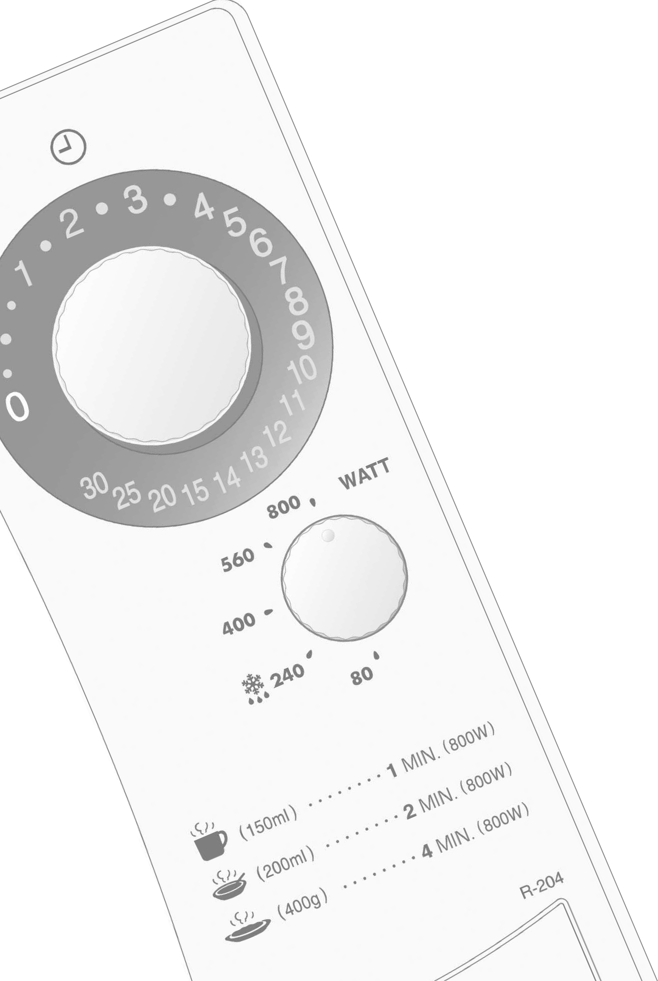
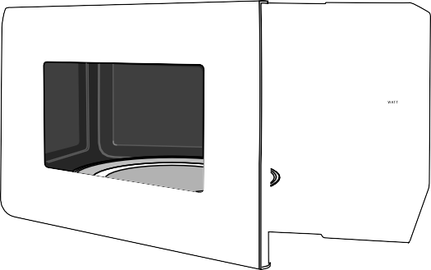

Attention

0

30 11
25 20 15 14 13 12

800
560

400

240
80

R- 204

MICROWAVE OVEN - OPERATION MANUAL WITH COOKBOOK

GB
ENGLISH
This operation manual contains important information which you should read carefully before using your microwave oven.
IMPORTANT: There may be a serious risk to health if this operation manual is not followed or if the oven is modified so that it operates with the door open.

800 W (IEC 60705)

ENGLISH

GB Dear Customer,
Congratulations on acquiring your new microwave oven, which from now on will make your kitchen chores considerably easier.
You will be pleasantly surprised by the kinds of things you can do with a microwave. Not only can you use it for rapid defrosting or heating up of food, you can also prepare whole meals.
In our test kitchen our microwave team has gathered together a selection of the most delicious international recipes which are quick and simple to prepare.
Be inspired by the recipes we have included and prepare your own favourite dishes in your microwave oven. There are so many advantages to having a microwave oven which we are sure you will find exciting:
- Food can be prepared directly in the serving dishes, leaving less to wash up.
- Shorter cooking times and the use of little water and fat ensure that many vitamins, minerals and characteristic flavours are preserved.
We advise you to read the cookery book guide and operating instructions carefully. You will then easily understand how to use your oven.
Enjoy using your microwave oven and trying out the delicious recipes.

CONTENTS OPERATION MANUAL
GB
OVEN AND ACCESSORIES 5-6
CONTROL PANELS 7
IMPORTANT SAFETY INSTRUCTIONS 56-58
INSTALLATION 58
MICROWAVE POWER LEVEL. 59
MICROWAVE COOKING 59
CARE AND CLEANING 60
SERVICE CALL CHECK 60

COOKBOOK
WHAT ARE MICROWAVES? 61
SUITABLE OVENWAREL 61
TIPS AND ADVICE 62-64
TABLES AND RECIPES 65-71
SERVICE ADDRESSES 72-77
SPECIFICATIONS 79

FORNO/UUNI/UGNEN/OVEN

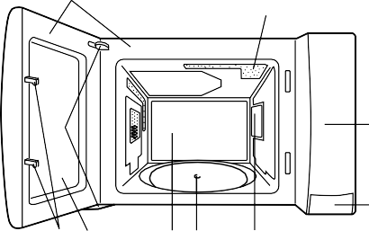
1
9
10
8

2
7 6 5 4 3

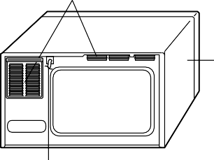
11

12

13
GB

- Control panel
- Door opening button
- Waveguide cover
- Seal packing
- Oven cavity
- Door
ENGLISH
- Door safety latches
- Door hinges
- Door seals and sealing surfaces
- Oven lamp
- Ventilation openings
- Outer cabinet
- Power cord

ACESSÓRIOS/LISÄVARUSTEET/TILLBEHÖR/ACCESSORIES

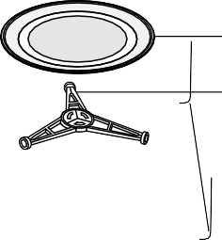
14

15

Seal packing

ACCESSORIES
GB
Check to make sure the following accessories are provided:
(14) Turntable (15) Roller stay
- Place the roller stay in the seal packing on the floor of the cavity.
- Then place the turntable on the roller stay.
- To avoid turntable damage, ensure dishes or containers are lifted clear of the turntable rim when removing them from the oven.
NOTE: When you order accessories, please mention two items: part name and model name to your dealer or SHARP authorised service agent.

PAINÉIS DE CONTROLO/SÄÄTÖPANEELIT/ KONTROLLPANELEN/CONTROL PANELS

GB
- Timer (0 - 30 Min.)
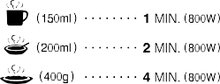
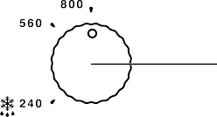
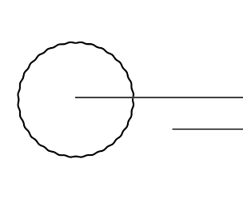
- Light display.
- Microwave power control.
- Menu guide.
These are the cooking guides for 1serve. Use 800W power level.
- Door opening button.

1
2

3

4

5
ENGLISH

IMPORTANT SAFETY INSTRUCTIONS

IMPORTANT SAFETY INSTRUCTIONS: READ CAREFULLY AND KEEP FOR FUTURE REFERENCE

To avoid the danger of fire.

Check the settings after you start the oven to ensure the oven is operating as desired.
The microwave oven should not be left unattended during operation. Power levels that are too high, or cooking times that are too long, may overheat foods resulting in a fire.
See the corresponding hints in operation manual and the cookery book section.
To avoid the possibility of injury

This oven is not designed to be built into a kitchen unit. The electrical outlet must be readily accessible so that the unit can be unplugged easily in an emergency. The AC power supply must be 230V, 50Hz, with a minimum 10A distribution line fuse, or a minimum 10A distribution circuit breaker.
WARNING:
Do not operate the oven if it is damaged or malfunctioning. Check the following before use:
- The door; make sure the door closes properly and ensure it is not misaligned or warped.
- The hinges and safety door latches; check to make sure they are not broken or loose.
- The door seals and sealing surfaces; ensure that they have not been damaged.
- Inside the oven cavity or on the door; make sure there are no dents.
- The power supply cord and plug; ensure that they are not damaged.
Never adjust, repair or modify the oven yourself. It is hazardous for anyone other than a competent person to carry out any service or repair operation which involves the removal of a cover which gives protection against exposure to microwave energy.
It is recommended that a separate circuit serving only this appliance be provided.
Do not place the oven in areas where heat is generated. For example, close to a conventional oven.
Do not install the oven in an area of high humidity or where moisture may collect.
Do not store or use the oven outdoors.

Do not operate the oven with the door open or alter the door safety latches in any way.
If food being heated begins to smoke, DO NOT OPEN THE DOOR. Turn off and unplug the oven and wait until the food has stopped smoking. Opening the door while food is smoking may cause a fire.
Use only microwave-safe containers and utensils. See Page 61.
Do not leave the oven unattended when using disposable plastic, paper or other combustible food containers.
Clean the waveguide cover, the oven cavity, the turntable and roller stay after use. These must be dry and free from grease. Built-up grease may overheat and begin to smoke or catch fire.
Do not operate the oven if there is an object between the door seals and sealing surfaces.
Do not allow grease or dirt to build up on the door seals and adjacent parts. Follow instructions for “Care and Cleaning”, Page 60.

Do not place flammable materials near the oven or ventilation openings. Do not block the ventilation openings.
Remove all metallic seals, wire twists, etc., from food and food packages. Arcing on metallic surfaces may cause a fire.
Do not use the microwave oven to heat oil for deep frying. The temperature cannot be controlled and the oil may catch fire.
To make popcorn, use only special microwave popcorn makers.
Do not store food or any other items inside the oven.
Individuals with PACEMAKERS should check with their doctor or the manufacturer of the pacemaker for precautions regarding microwave ovens.
To avoid the possibility of electric shock Under no circumstances should you remove the outer cabinet.
Never spill or insert any objects into the door lock openings or ventilation openings. In the event of a spill, turn off and unplug the oven immediately, and call an authorised SHARP service agent.
Do not immerse the power supply cord or plug in water or any other liquid.
Do not let the power supply cord hang over the edge of a table or work surface.

IMPORTANT SAFETY INSTRUCTIONS

Keep the power supply cord away from heated surfaces, including the rear of the oven.
Do not attempt to replace the oven lamp yourself or allow anyone who is not an electrician authorised by SHARP to do so. If the oven lamp fails, please consult your dealer or an authorised SHARP service agent. If the power supply cord of this appliance is damaged, it must be replaced with a special cord. The exchange must be made by an authorised SHARP service agent.
To avoid the possibility of explosion and sudden boiling:
WARNING: Liquids and other foods must not be heated in sealed containers since they are liable to explode.
Never use sealed containers. Remove seals and lids before use. Sealed containers can explode due to a build up of pressure even after the oven has been turned off.
Take care when microwaving liquids. Use a wide- mouthed container to allow bubbles to escape.
Never heat liquids in narrow necked containers such as baby bottles, as this may result in the contents erupting from the container when heated and cause burns.
To avoid the possibility of burns
Use pot holders or oven gloves when removing food from the oven to prevent burns.
Always open containers, popcorn makers, oven cooking bags, etc., away from the face and hands to avoid steam burns and eruption of boiling.

To avoid burns, always test food temperature and stir before serving and pay special attention to the temperature of food and drink given to babies, children or the elderly.
Temperature of the container is not a true indication of the temperature of the food or drink; always check the food temperature.
Always stand back from the oven door when opening it to avoid burns from escaping steam and heat.
Slice stuffed baked foods after heating to release steam and avoid burns.
Keep children away from the door to prevent them burning themselves.
To avoid misuse by children
WARNING: Only allow children to use the oven without supervision when adequate instructions have been given so that the child is able to use the oven in a safe way and understands the hazards of improper use.

To prevent sudden eruption of boiling liquid and possible scalding:
- Do not use excessive amount of time (See page 65).
- Stir liquid prior to and during heating/reheating.
- It is advisable to insert a glass rod or similar utensil (not metal) into the liquid whilst reheating.
- Let liquid stand about 20 seconds in the oven at the end of cooking time to prevent delayed eruptive boiling.
Do not cook eggs in their shells, and whole hard boiled eggs should not be heated in microwave ovens since they may explode even after microwave cooking has ended. To cook or reheat eggs which have not been scrambled or mixed, pierce the yolks and the whites, or the eggs may explode. Shell and slice hard boiled eggs before reheating them in the microwave oven.
Pierce the skin of such foods as potatoes, sausages and fruit before cooking, or they may explode.

Do not lean or swing on the oven door. Do not play with the oven or use it as a toy.
Children should be taught all important safety instructions: use of pot holders, careful removal of food coverings; paying special attention to packaging (e.g. self-heating materials) designed to make food crisp, as they may be extra hot.
ENGLISH
Other warnings
Never modify the oven in any way.
Do not move the oven while it is in operation.
This oven is for home food preparation only and may only be used for cooking food. It is not suitable for commercial or laboratory use.
To promote trouble-free use of your oven and avoid damage.
Never operate the oven when it is empty.
When using a browning dish or self-heating material, always place a heat-resistant insulator such as a porcelain plate under it to prevent damage to the turntable and roller stay due to heat stress. The preheating time specified in the dishes instructions must not be exceeded.
Do not use metal utensils, which reflect microwaves and may cause electrical arcing. Do not put cans in the oven.

IMPORTANT SAFETY INSTRUCTIONS

Use only the turntable and the roller stay designed for this oven. Do not operate the oven without the turntable.
To prevent the turntable from breaking:
- Before cleaning the turntable with water, leave the turntable to cool.
- Do not put hot foods or hot utensils on a cold turntable.
- Do not put cold foods or cold utensils on a hot turntable.
Do not place anything on the outer cabinet during operation.
NOTE:
If you are unsure how to connect your oven, please consult an authorised, qualified electrician.
Neither the manufacturer nor the dealer can accept any liability for damage to the oven or personal injury resulting from failure to observe the correct electrical connection procedure.
Water vapour or drops may occasionally form on the oven walls or around the door seals and sealing surfaces. This is a normal occurrence and is not an indication of microwave leakage or a malfunction.

INSTALLATION

- Remove all packing materials from the inside of the oven cavity. Discard the loose polythene sheet from between the door and cavity. Remove the feature sticker, if attached, from the outside of the door.
Do not remove the protective film attached to the
inside of the door.

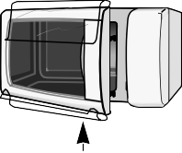
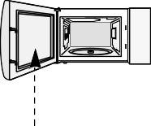

✓

✗
REMOVE DO NOT REMOVE

- Check the oven carefully for any signs of damage.
- Place the oven on a flat, level surface strong enough to support the oven’s weight plus the heaviest item likely to be cooked.

- Ensure there is a minimum free space above the oven of 15cm:

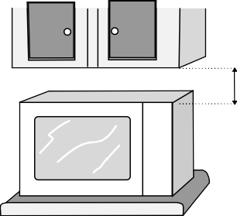
15cm

- Securely connect the plug of the oven to a standard earthed (grounded) household electrical outlet.
- Make sure that the TIMER is set to the “0” (off) position.

MICROWAVE POWER LEVEL

Your oven has 5 power levels. To choose the power level for cooking, follow the advice given in the recipe section. Generally the following recommendations apply:
800 W used for fast cooking or reheating e.g. soup, casseroles, canned food, hot beverages, vegetables, fish, etc.
560 W used for longer cooking of dense foods such as roast joints, meat loaf and plated meals, also for sensitive dishes such as cheese sauce and sponge cakes. At this reduced setting, the sauce will not boil over and food will cook evenly without over cooking at the sides.
400 W for dense foods which require a long cooking time when cooked conventionally, eg. beef dishes, it is advisable to use this power setting to ensure the meat will be tender.
240 W to defrost, select this power setting, to ensure that the dish defrosts evenly. This setting is also ideal for simmering rice, pasta, dumplings and cooking egg custard.
80 W For gentle defrosting, eg. cream gateaux or pastry.

COOKING TIPS:
In the cookbook section, you will find detailed instructions for recipe preparation, only basic cooking hints are given here.
- Push the door opening button, and the door will open, then place the food on the turntable.
- If you wish to stop cooking before the cooking time has elapsed, turn the TIMER back to “0” (off), or open the oven door. The oven door may be opened at any time during cooking (the TIMER will stop to indicate how much cooking time remains). To continue cooking, close the door. If you wish to change the cooking time during cooking, simply turn the TIMER to the desired new setting.
WARNING:
Be sure to turn the TIMER back to “0” (off) position after cooking, or the oven will start when the oven door is closed.
MICROWAVE COOKING

560

800
- Set the microwave POWER CONTROL to the desired setting.

400
ENGLISH

240
80

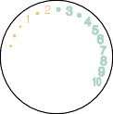
0
30
25 20 15 14 13 12
11

2. Set the TIMER to the desired cooking time.
The oven starts cooking, and the light display will count down.
When cooking has finished, the TIMER will return to “0”, the audible signal will sound, and the oven and oven lamp will turn off automatically.

NOTES:
- Your oven can be programmed up to 30 Minutes. The input unit of cooking or defrosting time varies from 15 seconds to 5 minutes, depending on the total cooking/defrosting time, as marked on the LIGHT DISPLAY.

- Your microwave oven is equipped with a safety function to avoid unintended use. The TIMER can be set to operate the microwave oven only within 3 minutes after a cooking cycle ends or after closing the oven door. Otherwise the oven door must be opened and closed again, before the TIMER can be set.

CARE AND CLEANING

CAUTION: DO NOT USE COMMERCIAL OVEN CLEANERS, ABRASIVE, HARSH CLEANERS OR SCOURING PADS ON ANY PART OF YOUR MICROWAVE OVEN.
Oven exterior
The outside of your oven can be cleaned easily with mild soap and water. Make sure the soap is wiped off with a moist cloth, and dry the exterior with a soft towel.
Oven controls
Open the door before cleaning to de-activate the oven controls. Care should be taken when cleaning the oven controls. Using a cloth dampened with water only, gently wipe the panel until it becomes clean. Avoid using excessive amounts of water. Do not use any sort of chemical or abrasive cleaner.
CAUTION:
Take care not to move the TIMER knob from “0” (off) position during cleaning, or the oven will start as soon as you close the door.
Oven Interior
- For cleaning, wipe any splatters or spills with a soft damp cloth or sponge after each use while the oven is still warm. For heavier spills, use a mild soap and wipe several times with a damp cloth until all residues are removed. Do not remove the waveguide cover.
- Make sure that mild soap or water does not penetrate the small vents in the walls which may cause damage to the oven.
- Do not use spray type cleaners on the oven interior.
Turntable and Roller stay
Remove the turntable and roller stay from the oven. Wash the turntable and roller stay in mild soapy water. Dry with a soft cloth. Both the turntable and the roller stay are dishwasher safe.
Door
To remove all trace of dirt, regularly clean both sides of the door, the door seals and sealing surfaces with a soft, damp cloth.

SERVICE CALL CHECK

Please check the following before calling for service.
  - Power Supply.
Check the power plug is properly connected to a suitable wall outlet. Check the line fuse/circuit breaker is functioning properly.
  - Place a cup of water (approx. 150 ml) in the oven and close the door securely. Programme the oven for one minute on 800W power and start the oven.
Does the oven lamp come on? YES NO
Does the turntable rotate? YES NO
NOTE: The turntable turns in either direction.
Does the ventilation work? YES NO (Place your hand over the ventilation openings and check for air flow.)
After 1 minute does the signal sound? YES NO
Is the water warm after the above operation? YES NO

If you answer “No” to any of the above questions, call a Service Technician appointed by SHARP and report the results of your check. See inside back cover for details of address.

NOTE: 1. If the oven door is opened, the audible signal will not sound when the TIMER returns to “0”.
- If you cook the food over the standard time with only 800 W, the power of the oven will lower automatically to avoid overheating. (The microwave power level will be reduced).

Cooking Mode | Standard time
Microwave 800 W | 20 minutes

WHAT ARE MICROWAVES?

Microwaves are generated in the microwave oven by a magnetron and cause the water molecules in the food to oscillate.
Heat is generated by the friction which is caused, with the result that the food is thawed, heated or cooked.

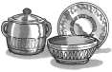
SUITABLE OVENWARE

GLASS AND CERAMIC GLASS
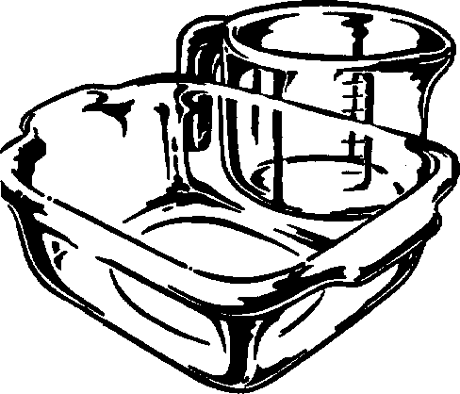
Heat-resistant glass utensils are very suitable. The cooking process can be observed from all sides. They must not, however, contain any metal (e.g. lead crystal), nor have a
metallic overlay (e.g. gold edge, cobalt blue finish).

CERAMICS
Generally very suitable. Ceramics must be glazed, since with unglazed ceramics moisture can get into the ceramic. Moisture causes the material to heat up and may make it shatter. If you are not certain whether your utensil is suitable for the microwave, carry out the utensil suitability test.

PORCELAIN
Very suitable. Ensure that the porcelain does not have a gold or silver overlay and that it does not contain any metal.

PLASTIC AND PAPER UTENSILS
Heat resistant plastic utensils which are suitable for use in the microwave can be used to thaw, heat and cook food. Follow the manufacturer's recommendations.
Heat-resistant paper made for use in a microwave oven is also suitable. Follow the manufacturer's recommendations.

MICROWAVE FOIL
This, or heat-resistant foil, is very suitable for covering or wrapping. Please follow the manufacturer's recommendations.

ROASTING BAGS
Can be used in a microwave oven. Metal clips are not suitable for fastening them since the roasting bag foil might melt. Fasten the roasting bag with string and pierce it several times with a fork. Non heat- resistant food wraps are not recommended for use in a microwave oven.

BROWNING DISH
A special microwave dish made from ceramic glass with
a metal alloy base, which allows food to be browned. When using the browning dish a suitable insulator,
e.g. a porcelain plate, must be placed between the turntable and the browning dish. Be careful to adhere exactly to the pre-heating time given in the manufacturer's instructions. Excessive pre-heating can damage the turntable and the turntable stand or can trigger the safety-device which will switch off the oven.

METAL
Generally speaking, metal should not be used, since microwaves do not pass through metal and therefore cannot reach the food. There are, however, exceptions: small strips of aluminium foil may be used to cover certain parts of the food, so that these do not thaw too quickly or begin to cook (e.g. chicken wings). Small metal skewers and aluminium containers (e.g. of ready-cooked meals) can be used. They must, however, be small in relation to the food,
e.g. aluminium containers must be at least 2/3 to 3/4 filled with food. It is recommended that you transfer the food into a dish suitable for use in the microwave. When using aluminium containers or other metal utensils there must be a gap of approx. 2 cms between them and the walls of the cooking area, otherwise the walls could be damaged by possible arcing.
ENGLISH

NO UTENSIL SHOULD HAVE A METAL
OVERLAY - parts such as screws, bands or handles.

UTENSIL SUITABILITY TEST
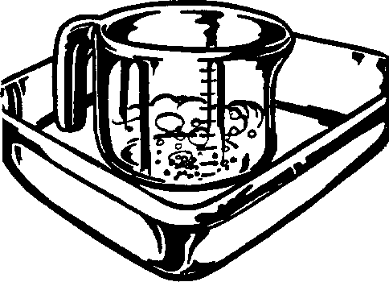
If you are not sure whether your utensil is suitable for use in your microwave oven, carry out the following test: Place the utensil into the oven. Place a glass container
filled with 150 ml of water on or next to the utensil. Switch on the oven at 800 W power for 1 to 2 minutes. If the utensil stays cool or just warm to the touch, it is suitable. Do not use this test on a plastic utensil. It could melt.

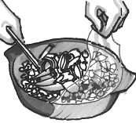
TIPS AND ADVICE

TIME SETTINGS
In general the thawing, heating and cooking times are significantly shorter than when using a conventional cooker or oven. For this reason you should adhere to the recommended times given in this cookery book. It is better to set the times too short, rather than too long. Test the food after it has been cooked. It is better to have to cook something for a little longer than to overcook it.

INITIAL TEMPERATURES
Thawing, heating and cooking times are dependent upon the initial temperature of the food. Deep-frozen food and food stored in a refrigerator, for example, requires longer than food which has been stored at room temperature.
For heating and cooking, normal storage temperatures are assumed (refrigerator temperature approx. 5° C, room temperature approx. 20° C). For thawing the temperature of the deep freeze is assumed to be - 18° C.

COOKING TIMES
All the times given in this cookery book are guidelines, which can be varied according to the initial temperature, weight and condition of the food (water or fat content etc.).

SALT, SPICES AND HERBS
Food cooked in your microwave retains its individual flavour better than it does when conventional preparation methods are used. For this reason you should use salt very sparingly and normally add it only after cooking. Salt absorbs liquid and dries out the outer layer of the food. Herbs and spices can be used as normal.

ADDITION OF WATER
Vegetables and other foods with a high water content can be cooked in their own juice or with the addition of a little water. This ensures that many vitamins and minerals are preserved.

FOOD IN SKINS OR SHELLS
Food such as sausages, chickens, chicken legs, baked potatoes, tomatoes, apples, egg yolks or such like should be pricked or pierced with a fork or small wooden skewer. This will enable the steam which forms to dissipate without splitting the skin or shell.

LARGE AND SMALL QUANTITIES
Microwave times are directly dependent upon the amount of food which you would like to thaw, heat or cook. This means that small portions cook more quickly than larger ones.
As a rule of thumb:
TWICE THE AMOUNT = ALMOST TWICE THE TIME HALF THE AMOUNT = HALF THE TIME

DEEP AND SHALLOW CONTAINERS
Both containers have the same capacity, but the cooking time is longer for the deeper one. You should therefore choose as flat a container as possible with a large surface area. Only use deep containers for dishes where there is a danger of overcooking, e.g. for noodles, rice, milk etc..

ROUND AND OVAL CONTAINERS
Food cooks more evenly in round or oval containers than in containers with corners, since the microwave energy concentrates in the corners and the food in these areas could become overcooked.

COVERING
Covering the food retains the moisture within it and shortens the cooking time. Use a lid, microwave foil or a cover. Foods which are to be crispy, e.g. roasts or chickens, should not be covered.
As a general rule, whatever would be covered in a conventional oven should also be covered in a microwave oven. Whatever would be uncovered in an ordinary oven can also be left uncovered in
a microwave oven.

TURNING
Medium-sized items, such as hamburgers and steaks, should be turned over once during cooking, in order to shorten the cooking process. Large items, such as roasts and chickens, must be turned, since the upper side receives more microwave energy and could dry out if not turned.

STANDING TIME
Keeping to the standing time is one of the most important rules with microwaves. Almost all foods, which are thawed, heated or cooked in the microwave, require a certain amount of time to stand, during which temperature equalisation takes place and the moisture in the food is evenly distributed.

TIPS AND ADVICE

BROWNING AGENTS
After more than 15 minutes cooking time food acquires a brownness, although this is not comparable to the deep brownness and crispness obtained through conventional cooking. In order
to obtain an appetising brown colour you can use browning agents. For the most part they simultaneously act as seasoning agents.

In the following table you will find some suggestions for substances you might use for browning and some of the uses to which you might put them.

BROWNING AGENT DISH METHOD

Melted butter and dried paprika | Poultry | Coat the poultry with the  butter/paprika mixture
Dried paprika | Oven baked dishes"Cheese toasties" | Dust with paprika
Soya sauce | Meat and poultry | Coat with the sauce
Barbecue and Worcestershire sauce, Gravy | Roasts, Rissoles, Small roasted  items | Coat with the sauce
Rendered down bacon fat or dried onions | Oven baked dishes, toasted  items, soups, stews | Sprinkle pieces of bacon or  dried onions on top
Cocoa, chocolate flakes, brown icing, honey and marmalade | Cakes and desserts | Sprinkle pieces on top of cakes and desserts or use to glaze

HEATING
- Ready-prepared meals in aluminium containers should be removed from the aluminium container and heated on a plate or in a dish.
- Remove the lids from firmly closed containers.
- Food should be covered with microwave foil, a plate or cover (obtainable from stores), so that the surface does not dry out. Drinks need not be covered.
- When boiling liquids such as water, coffee, tea or milk, place a glass stirrer in the container.
- If possible, stir large quantities from time to time, to ensure that the temperature is evenly distributed.
- The times are for food at a room temperature of 20° C. The heating time for food stored in a refrigerator should be increased slightly.
- After heating allow the food to stand for 1-2 minutes, so that the temperature inside the food can be evenly distributed (standing time).
- The times given are guidelines, which can be varied according to the initial temperature, weight, water content, fat content or the result which you wish to achieve.

THAWING
Your microwave is ideal for thawing. Thawing times are usually considerably shorter than in traditional
methods of thawing.
Here are a few tips. Take the frozen item out of its packaging and place on a plate for thawing.

BOXES AND CONTAINERS
Boxes and containers suitable for microwaves are particularly good for thawing and heating food, since they can withstand temperatures in a deep freeze (down to approx. –40° C) as well as being heat-resistant (up to approx. 220° C). You can therefore use the same container to thaw, heat and even cook the food, without having to transfer it.
ENGLISH

COVERING
Cover thin parts with small strips of aluminium foil before thawing. Thawed or warm parts should likewise be covered with aluminium strips during thawing. This stops the thin parts becoming too hot while thicker parts are still frozen.

CORRECT SETTING
It is better to choose a setting which is too low rather than one which is too high. By so doing you will ensure that the food thaws evenly.
If the microwave setting is too high, the surface of the food will already have begun to cook while the inside is still frozen.

TIPS AND ADVICE

TURNING/STIRRING
Almost all foods have to be turned or stirred from time to time. As early as possible, separate parts which are stuck together and rearrange them.

SMALL AMOUNTS
Thaw more quickly and evenly than larger ones. We recommend that you freeze portions which are as small as possible. By so doing you will be able to prepare whole menus quickly and easily.

FOODS REQUIRING CAREFUL HANDLING
Foods such as gateaux, cream, cheese and bread should only be partially thawed and then left to thaw completely at room temperature. By so doing you will avoid the outer areas becoming too hot while the inside is still frozen.

STANDING TIME
This is particularly important after thawing food, as the thawing process continues during this period. In the thawing table you will find the standing times for various foods. Thick, dense foods require a longer standing time than thinner foods or foodof a porous nature. If the food has not thawed sufficiently, you may continue thawing it in the microwave oven or lengthen the standing time accordingly. At the end of the standing time youshould process the food as soon as possible and not re-freeze it.

COOKING FRESH VEGETABLES
- When buying vegetables try to ensure that, as far as possible, they are of similar size. This is particularly important when you want to cook the vegetables whole (e.g. boiled potatoes).
- Wash the vegetables before preparing them, clean them and only then weigh the required quantity for the recipe and chop them up.
- Season them as you would normally, but as a rule only add salt after cooking.
- Add about 5 tbsps of water for 500 g of vegetables. Vegetables which are high in fibre require a little more water. You will find information about this in the table.
- Vegetables are usually cooked in a dish with a lid. Those with a high moisture content, e.g. onions or boiled potatoes, can be cooked in microwave foil without adding water.
- After half the cooking time has elapsed vegetables should be stirred or turned over.
- After cooking allow the vegetables to stand for approx. 2 minutes, so that the temperature disperses evenly (standing time).
- The cooking times given are guidelines and depend upon the weight, initial temperature and condition of the type of vegetable in question. The fresher the vegetables, the shorter the cooking times.

COOKING MEAT, FISH AND POULTRY
- When buying food items, try to ensure that, as far as possible, they are of similar size. This will ensure that they are cooked properly.
- Before preparation wash meat, fish and poultry thoroughly under cold running water and pat them dry with kitchen paper. Then continue as normal.
- Beef should be well hung and have little gristle.
- Even though the pieces may be of a similar size, cooking results may vary. This is due, amongst other things, to the kind of food, variations in the fat and moisture content as well as the temperature before cooking.
- After the food has been cooking for 15 minutes it acquires a natural brownness, which may be enhanced by the use of a browning agent. If, in addition, you would like the surface to be crisp you should either use the browning dish or sear the food on your cooker and finish cooking it in your microwave. By doing this you will simultaneously obtain a brown base for making a sauce.
- Turn large pieces of meat, fish or poultry half way through the cooking time, so that they are cooked evenly from all sides.
- After cooking cover roasts with aluminium foil and allow them to stand for approx. 10 minutes (standing time). During this period the roast carries on cooking and the liquid is evenly distributed, so that when it is carved a minimum amount of juice is lost.

THAWING AND COOKING
Deep-frozen dishes can be thawed and cooked at the same time in one process in your microwave. You will find some examples in the table. Do take note, however, of the general advice given on "heating" and "thawing" food. Please refer to the manufacturer's instructions on the packaging when preparing deep- frozen dishes. These usually contain precise cooking times and offer advice on preparation.

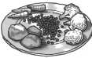
TABLES

ABBREVIATIONS USED
tbsp = tablespoon
tsp = teaspoon
l.p. = large pinch
s.p. = small pinch Cup = cupful Sach. = sachet
KG = kilogram
g = gram l = litre
ml = millilitre cm = centimetre
DFC = dry fat content
DF = deep frozen
MW = microwave
MWO = microwave oven min = minutes
sec = seconds dm = diameter

Food / Drink
Quantity | Power | Time | Hints
-g/ml- | -Setting- | -Min-

TABLE: HEATING FOOD AND DRINK

Coffee, | 1 cup | 150 | 800W | approx.1 |  | do not cover
Milk, | 1 cup | 150 | 800W | approx.1 |  | do not cover
Water, | 1 cup  6 cups  1 bowl | 150  900  1000 | 800W  800W  800W | 11/2 -2  10-12  10-12 |  | do not cover, bring to the boil  do not cover, bring to the boil do not cover, bring to the boil
Platters  (Vegetables, meat and trimmings) |  | 400 | 800W | approx.4 |  | sprinkle some water onto the sauce, cover  stir half way through the heating time
Stew |  | 200 | 800W | 2-3 |  | cover, stir after heating
Clear soup  Cream soup |  | 200  200 | 800W  800W | approx.2  approx.2 |  | cover, stir after heating  cover, stir after heating
Vegetables |  | 200  500 | 800W  800W | 2-3  4-5 |  | if necessary add some water, cover  stir half way through the heating time
Garnishes |  | 200  500 | 800W  800W | 1-2  4-5 |  | sprinkle with water, cover and stir from time to  time.
Meat, | 1 slice* | 200 | 800W | 3-4 |  | thinly spread sauce over the top, cover
Fish fillet* |  | 200 | 800W | 2-3 |  | cover
Sausages 2 |  | 180 | 560W | approx.2 |  | pierce the skin several times
Cake, 1 piece |  | 100 | 400W | 1/2 |  | place on a cake stand
Baby food, 1 glass |  | 190 | 400W | approx.1 |  | remove the lid, after heating stir well and test the  temperature
Melting butter or margarine* |  | 50 | 800W | 1/2 | -1
Melting chocolate |  | 100 | 400W | 2-3 |  | stir from time to time
Dissolving six sheets of gelatine |  | 10 | 400W | 1/2 |  | dip into water, squeeze thoroughly and place in  a soup bowl, stir from time to time
Glazing for a tart for 1/4 1 of liquid |  | 10 | 400W | 5-6 |  | mix the sugar in 250 ml of liquid, cover, stir well  during and after heating
* Refrigerator temperature
ENGLISH

TABLE: COOKING MEAT, FISH AND POULTRY
Fish and Poultry | Quantity Power Time | Hints | Standing time
 | -g- -Setting- -Min- |  | -Min-

Roasts | 500 | 800W | 8-10* | season to taste, place in a shallow flan dish | 10
(pork, |  | 400W | 10-12 | turn over after *
veal, lamb) | 1000 | 800W | 20-22* |  | 10
 |  | 400W | 10-12
Roast beef (medium) | 1000 | 800W  400W | 9-11*  5-7 | season to taste, place in a quiche dish,  turn over after * | 10
Minced meat | 1000 | 800W | 16-18 | prepare the minced meat mixture (half pork/half beef)  place in a shallow casserole dish | 10
Fish fillet | 200 | 800W | 3-4 | season to taste, place on a plate, cover | 3
Chicken | 1200 | 800W | 20-22 | season to taste, place in a casserole dish,  turn half way through cooking time | 3
Chicken legs | 200 | 800W | 3-4 | season to taste, place on a plate, cover | 3

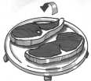
TABLES

TABLE: THAWING
Food Quantity Power Thawing time Hints Standing time
-g- -Setting- -Min- -Min-
Roast meat (e.g. pork, beef, lamb, veal) | 1500  1000  500 | 80W  80W  80W | 58-64  42-48  18-20 | place on an upturned plate, turn half way through thawing time | 30-90  30-90  30-90
Steaks, escalopes, cutlets, liver | 200 | 80W | 7-8 | turn half way through thawing time | 30
Goulash | 500 | 240W | 8-12 | separate and stir half way through thawing time | 10-15
Sausages, 8  4 | 600  300 | 240W  240W | 6-9  4-5 | place next to each other,  turn half way through thawing time | 5-10  5-10
Duck, turkey | 1500 | 80W | 48-52 | place upon an upturned plate,  turn half way through thawing time | 30-90
Chicken | 1200  1000 | 80W  80W | 39-43  33-37 | place upon an upturned plate,  turn half way through thawing time place upon an upturned plate,  turn half way through thawing time | 30-90  30-90
Chicken legs | 200 | 240W | 4-5 | turn half way through thawing time | 10-15
Whole fish | 800 | 240W | 9-12 | turn half way through thawing time | 10-15
Fish fillet | 400 | 240W | 7-10 | turn half way through thawing time | 5-10
Crabs | 300 | 240W | 6-8 | turn half way through thawing time | 30
Rolls, 2 | 80 | 240W | app.1 | only partially thaw | -
Sliced bread for toasting | 250 | 240W | 2-4 | remove outer slices after each minute has passed | 5
White loaf, whole 750 240W 7-10 turn half way through thawing time (centre still frozen) 30
Cakes, per piece | 100-150 | 80W | 2-5 | place on a cake stand | 5
Cream cake, per piece | 150 | 80W | 3-4 | place on a cake stand | 10
Whole gateau, Ø 25cm |  | 80W | 20-24 | place on a cake stand | 30-60
Butter | 250 | 240W | 2-4 | only partially thaw | 15
Fruit such as strawberries  raspberries, cherries, plums | 250 | 240W | 4-5 | spread them out evenly  turn half way through thawing time | 5

TABLE: THAWING AND COOKING

Food | Quantity Power Cooking time Added water | Hints | Standing time
 | -g- -Setting- -Min- -tbsps/ml- |  | -Min-

Fish fillet | 300 | 800W | 10-11 | - | cover |  | 1-2
Trout, 1 fish | 250 | 800W | 7-9 | - | cover
Platter | 400 | 800W | 8-9 | - | cover, stir | half way through cooking time | -
Leaf spinach | 300 | 800W | 7-9 | - | cover, stir | once or twice during cooking | 2
Broccoli | 300 | 800W | 7-9 | 3-5tbsps | cover, stir | half way through cooking time | 2
Peas | 300 | 800W | 7-9 | 3-5tbsps | cover, stir | half way through cooking time | 2
Kohlrabi | 300 | 800W | 7-9 | 3-5tbsps | cover, stir | half way through cooking time | 2
Mixed vegetables | 500 | 800W | 12-14 | 3-5tbsps | cover, stir | half way through cooking time | 2
Brussels sprouts | 300 | 800W | 7-9 | 3-5tbsps | cover, stir | half way through cooking time | 2
Red cabbage | 450 | 800W | 11-13 | 3-5tbsps | cover, stir | half way through cooking time | 2

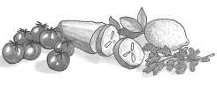
TABLES

TABLE: COOKING FRESH VEGETABLES
Vegetable Quantity Power Time Hints Added Water
-g- -Setting -Min- -tbsps/ml-
Leaf Spinach | 300 | 800W | 5-7 | wash dry well, cover, stir once or twice during cooking | -
Cauliflower | 800  500 | 800W  800W | 15-17  10-12 | 1 whole head, cover, divide into florets, stir  during cooking | 5-6tbsps  4-5tbsps
Broccoli | 500 | 800W | 10-12 | divide into florets, cover, stir occasionally during cooking | 4-5tbsps
Mushrooms | 500 | 800W | 8-10 | whole heads, cover, stir occasionally during cooking | -
Chinese leaves | 300 | 800W | 9-11 | cut into strips, cover, stir occasionally during cooking | 4-5tbsps
Peas | 500 | 800W | 9-11 | cover, stir occasionally during cooking | 4-5tbsps
Fennel | 500 | 800W | 9-11 | cut into quarters, cover, stir occasionally during cooking | 4-5tbsps
Onions | 250 | 800W | 5-7 | whole, cook in microwave foil | -
Kohlrabi | 500 | 800W | 10-12 | dice, cover, stir occasionally during cooking | 50ml
Carrots | 500  300 | 800W  800W | 10-12  9-12 | cut into rings, cover, stir occasionally during cooking | 4-5tbsps
Green peppers | 500 | 800W | 7-9 | cut into strips, stir once or twice during cooking | 4-5tbsps
Boiled potatoes (skins on) | 500 | 800W | 9-11 | cover, stir occasionally during cooking | 4-5tbsps
Leeks | 500 | 800W | 9-11 | cut into rings, cover, stir occasionally during cooking | 4-5tbsps
Red cabbage | 500 | 800W | 10-12 | cut into strips, stir once or twice  during cooking | 50ml
Brussels sprouts | 500 | 800W | 9-11 | whole sprouts, cover, stir occasionally during cooking | 50ml
Boiled Potatoes (salted) | 500 | 800W | 9-11 | cut into large pieces of a similar size, add a little salt,  cover, stir occasionally during cooking | 150ml
Celery | 500 | 800W | 9-11 | dice finely, cover, stir occasionally during cooking | 50ml
White cabbage | 500 | 800W | 10-12 | cut into strips, cover, stir occasionally during cooking | 50ml
Courgettes | 500 | 800W | 9-11 | slice, cover, stir occasionally during cooking | 4-5tbsps

RECIPES

ADAPTING RECIPES FOR THE MICROWAVE OVEN
If you would like to adapt your favourite recipes for the microwave, you should take note of the following:
Shorten cooking times by a third to a half. Follow the example of the recipes in this cookery book.
Foods which have a high moisture content such as meat, fish, poultry, vegetables, fruit, stews and soups can be prepared in your microwave without any difficulty. Foods which have little moisture, such as platters of food, should have the surface moistened prior to heating or cooking.
The amount of liquid to be added to raw foods, which are to be braised, should be reduced to about two thirds of the quantity in the original recipe. If necessary, add more liquid during cooking.
The amount of fat to be added can be reduced considerably. A small amount of butter, margarine or oil is sufficient to flavour food. For this reason your microwave is excellent for preparing low-fat foods as part of a diet.

HOW TO USE RECIPES
ENGLISH
- All the recipes in this cookery book are calculated on the basis of 4 servings - unless otherwise stated.
- Recommendations relating to suitable utensils and the total cooking times are given at the beginning of every recipe.
- As a rule the quantities shown are assumed to be wholly consumable, unless specifically indicated otherwise.
- When eggs are given in the recipes they are assumed to have weight of approx. 55 g (grade M).

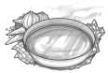
RECIPES

Germany

CAMEMBERT TOAST
Total cooking time: approx. 1-2 minutes Utensil:
Ingredients
4 slices of bread for toasting 2 tbsp butter or margarine (20 g) 150 g Camembert
4 tsp Cranberry jelly Cayenne pepper
- Toast the bread and spread with butter.
- Cut the Camembert into slices and arrange on top of the toast. Put the cranberry jelly in the middle of the cheese and sprinkle with cayenne pepper.
- Place the toast on a plate and heat for 1-2 Mins. 800 W
Tip: You can vary this recipe according to your taste. For example, you can use fresh mushrooms and grated cheese or cooked ham, asparagus and Emmental cheese.

Netherlands

MUSHROOM SOUP
Champignonsoep
Total cooking time: approx. 13-17 Minutes Utensil: Bowl with Lid (2 l Capacity) Ingredients
200 g mushrooms, sliced
1 onion (50 g), finely chopped
300 ml meat stock
300 ml Cream
21/2 tbsps Flour (25 g)
21/2 tbsps Butter or Margarine (25 g) Salt & Pepper
1 Egg
150 g Crème fraîche
- Place the vegetables and the stock in the bowl, cover and cook.
8-9 Mins. 800 W
- Blend all the ingredients in the mixer.
- Mix the flour and butter to a dough and smooth into the soup. Season with salt and pepper, cover and cook. Stir after cooking.
4-6 Mins. 800 W
- Mix the egg yolk with the cream, gradually stir into the soup. Heat for a short time, but do not let it boil! 1-2 Mins. 800 W
Allow the soup to stand for about 5 minutes after cooking.

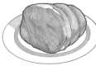
RECIPES

Switzerland

ZÜRICH VEAL IN CREAM
Total cooking time: approx. 12-16 minutes Utensil: dish with lid (2 l capacity) Ingredients
600 g veal fillet
1 tbsp butter or margarine
1 onion (50 g), finely chopped 100 ml white wine
Seasoned gravy browning, for approx. 1/2 l gravy 300 ml cream
1 tbsp parsley, chopped
  - Cut the fillet into finger-width strips.
  - Grease the dish all over with the butter. Put the onion and the meat into the dish, cover and cook. Stir once during cooking.
7-10 Mins. 800 W
  - Add the white wine, gravy browning and cream, stir, cover and continue cooking. Stir occasionally. 5-6 Mins. 800 W
  - Test the veal, stir the mixture once more and allow to stand for approx. 5 minutes. Serve garnished with parsley.

France

SOLE FILLETS
Total cooking time: approx. 11-14 minutes
Utensil: shallow,oval oven dish with microwave foil (approx. 26 cm long)
Ingredients
400 g sole fillets
1 lemon, whole
2 tomatoes (150 g)
1 tsp butter or margarine for greasing 1 tbsp vegetable oil
1 tbsp parsley, chopped
salt & pepper
4 tbsps white wine (40 ml)
2 tbsps butter or margarine (20 g)
- Wash the sole fillets and pat them dry. Remove any bones.
- Cut the lemon and the tomatoes into thin slices.
- Grease the oven dish with butter. Place the fish fillets inside and drizzle the vegetable oil over them.
- Sprinkle parsley over the fish, place the tomato slices on top and season. Place the lemon slices on top of the tomatoes and pour the white wine over them.
- Place small pats of butter on top of the lemon, cover and cook.
11-14 Mins. 800 W
After cooking allow the fish fillets to stand for approx. 2 minutes.
Tip: This recipe can also be used for Haddock, Halibut, Mullet, Plaice or Cod.
ENGLISH

Greece

BRAISED LAMB WITH GREEN BEANS
Total cooking time: approx. 20-24 minutes Utensil: shallow oval soufflé mould with lid (about 26 cm long)
Ingredients
1-2 tomatoes (100 g) 400 g lamb, boned
1 tsp butter or margarine for greasing the bowl
1 onion (50 g), finely chopped
1 clove garlic, crushed salt, pepper
sugar
250 g tinned green beans
- Skin and remove the stalks of the tomatoes, then purée in a blender or food processor.
- Cut the lamb into large chunks. Grease the bowl with butter. Add meat, onions and garlic, season, cover and cook.
9-11 Mins. 800 W
- Add beans and puréed tomatoes to the meat, cover and continue cooking.
11-13 Mins. 560 W
After cooking, leave the lamb to stand for approximately 5 minutes.
Tip: If you prefer to use fresh beans, these should be pre-cooked.

RECIPES

Italy

LASAGNE
Total cooking time 22-27 minutes Utensils: Bowl with lid (2 l capacity)
shallow square soufflé mould with lid (approx 20 x 20 x 6 cm)
Ingredients
300 g tinned tomatoes 50 g ham, finely cubed
- Cut the tomatoes into slices, mix with the ham and onion, garlic, minced meat and mashed tomato. Season and cook with the lid on.
7-9 Mins. 800 W
- Mix the cream with the milk, Parmesan cheese, herbs, oil, and spices.
- Grease the soufflé mould and cover the bottom of the mould with about 1/3 of the pasta. Put half of the minced meat mixture on the pasta and pour on some
1

sauce. Put an additional /3 of the pasta on top

1 onion (50 g), finely chopped
1 clove of garlic, crushed 250 g minced meat (beef)
2 tbsp mashed tomato (30 g) salt, pepper
oregano, thyme, basil, nutmeg 150 ml cream (crème fraîche)
100 ml milk
50 g grated Parmesan cheese 1 tsp mixed chopped herbs
1 tsp olive oil
1 tsp vegetable oil to grease the mould 125 g lasagne verde
1 tbsp grated Parmesan cheese 1 tbsp butter or margarine
followed by another layer of the minced meat mixture and some sauce, finishing with the remaining pasta on top. Finally, cover the pasta with lots of sauce and sprinkle with Parmesan cheese. Place butter flakes on top and cook with the lid on. 15-18 Mins. 560 W
After cooking, let the lasagne stand for approximately 5-10 minutes.

France

RATATOUILLE
Total cooking time 19-21 minutes Utensils: Bowl with lid (2 l capacity) Ingredients
5 tbsp olive oil (50 ml) 1 clove garlic, crushed
1 onion (50 g), sliced
1 small aubergine (250 g), cut into cubes
1 courgette (200 g), into cubes
1 pepper (200 g), cut into large cubes
1 Small fennel (75 g) cut into large cubes
1 bouquet garni
200 g tinned artichoke hearts, cut into quarters salt, pepper
- Place the olive oil and garlic clove in the bowl. Add the prepared vegetables, except the artichoke hearts, and season with pepper. Add the bouquet garni, cover and cook, stirring once.
19-21 Mins. 800 W
For the last 5 minutes, add the artichoke hearts and heat.
- Season the ratatouille to taste with salt and pepper. Remove the bouquet garni before serving. After cooking, leave the ratatouille to stand for around 2 minutes.
Tip: Ratatouille can be served hot with meat dishes. Served cold, it also makes an excellent starter.

A bouquet garni consists of: one stalk of parsley, a bunch of herbs suitable for seasoning soup, one stalk of lovage, one stalk of thyme, several bay leaves.

RECIPES

Spain

BAKED POTATOES
Total cooking time 12-16 minutes Utensils: Bowl with lid (2 l capacity)
China plate Ingredients
4 medium sized potatoes (400 g)
100 ml water
60 g ham, cut into fine cubes 1/2 onion (25 g) finely cubed 75-100 ml milk
2 tbsp grated Parmesan cheese (20 g) salt, pepper
2 tbsp grated Emmental cheese
- Place the potatoes in a dish, add the water, cover and cook. Rearrange halfway through cooking.
8-10 Mins. 800 W
Leave to cool.
- Cut the potatoes lengthwise and carefully remove the potato from the skin. Mix the potato with the ham, onion, milk and Parmesan cheese to an even consistency. Season with salt and pepper.
- Fill the potato skins with potato mixture and sprinkle with Emmental cheese. Place potatoes on a plate and cook.
4-6 Mins. 800 W
After cooking, leave to stand for approximately 2 minutes.

Denmark

FRUIT JELLY WITH VANILLA SAUCE
Total cooking time 10-13 minutes Utensils: Dish with lid (2 l capacity)
(1 l capacity)
Ingredients
150 g redcurrants, washed and stalks removed 150 g strawberries, washed and haulms removed 150 g raspberries, washed and haulms removed 250ml white wine
100 g sugar
50 ml lemon juice
8 gelatin leaves
300 ml milk
inside of 1/2 vanilla pod
30 g sugar
15 g food thickener

- Put some of the fruit to one side for decoration. Purée the rest of the fruit with the white wine, put it into a dish, cover and heat.
7-9 Min. 800 W
Fold in the sugar and the lemon juice.
- Soak the gelatin in cold water for approx. 10 minutes, then take it out and squeeze dry. Stir the gelatin in with the hot purée until it has dissolved. Place the jelly in the refrigerator and leave to set.
- To make the vanilla sauce; put the milk into the other dish. Slit the vanilla pod and remove the inside. Stir this in with the milk, together with the sugar and the food thickener, cover and cook, stirring during cooking and again at the end.
ENGLISH
3-4 Min. 800 W
- Turn out the jelly onto a plate and decorate with the whole fruit. Add the vanilla sauce.
Tip: You can also use defrosted frozen fruits.

71

GB
SPECIFICATIONS
GB

AC Line Voltage
Distribution line fuse/circuit breaker AC Power required: Microwave
Output power: Microwave Microwave Frequency
Outside Dimensions Cavity Dimensions Oven Capacity Turntable
Weight Oven lamp
: 230 V, 50 Hz, single phase
: Minimum 10 A
: 1,18 kW
: 800 W (IEC 60705)
: 2450 MHz
: 460 mm(W) × 275 mm(H) × 353 mm(D)
: 322 mm(W) × 187 mm(H) × 336 mm(D)
: 20 litres
: ∅ 272 mm
: approx. 12 kg
: 25 W/240-250 V

This equipment complies with the requirements of directives 89/336/EEC and 73/23/EEC
as amended by 93/68/EEC.

As part of a policy of continuous improvement, we reserve the right to alter design and specifications without notice.

SHARP ELECTRONICS (EUROPE) GMBH.
Sonninstrasse 3, 20097 Hamburg
Germany TINSZA073WRRZ-H21
Printed in Thailand

Downloaded from: http://www.usersmanualguide.com/

This file has been downloaded from:

www.UsersManualGuide.com

User Manual and User Guide for many equipments like mobile phones, photo cameras, monther board, monitors, software, tv, dvd, and othes..

Manual users, user manuals, user guide manual, owners manual, instruction manual, manual owner, manual owner's, manual guide, manual operation, operating manual, user's manual, operating instructions, manual operators, manual operator, manual product, documentation manual, user maintenance, brochure, user reference, pdf manual

