All of our electrical appliances conform to pre-existing EC Directives 2006/95/EC (Low
Voltage Directive) and 2004/108/EC (EMC Directives).

For further information please visit http://www.esc.org.uk/industry/product-safety/ product-testing-screening/kitchen-appliances/

UK & EU Guarantee

Your new Andrew James product comes with a 24 month guarantee and a 2 year fixed warranty, effective from receipt confirmation. Your receipt or order number is required as proof of purchase date so it is imperative that you keep it safe. This guarantee only applies if the item has been used solely for the use intended, and all instructions have been followed accordingly. Please note this product is for domestic use only and not for commercial use.
Abuse of your product will invalidate the guarantee. Returned goods can only be
accepted if repackaged properly within the original colour product box, and presented with the original receipt of sale/order number. This does not affect your statutory rights.
Returned products must be cleaned and returned to us in as close to delivery condition
as possible.

If your product develops a problem within the first 12 months of the fixed warranty, we will pay all shipping costs to have it returned to us. After 12 months the customer will be liable for the cost of returning the product to us. We will then pay to have the
repaired/replaced item shipped back to the customer.

If you wish to return your item for a full refund, you have the right to do so within the first 7 days. For our returns policy please go to www.andrewjamesworldwide.com
Customers are responsible for any taxes applied to our products when they are shipped
outside of the EU.

All of our prices are inclusive of VAT.

Once a product has been returned to us, we will aim to repair or replace it within 30 days of receipt.
The guarantee does not cover any defect arising from improper use, damage, build-up of lime scale or repair attempts made by third-parties. Also, the guarantee does not
cover normal wear and tear of individual parts.

Kettle

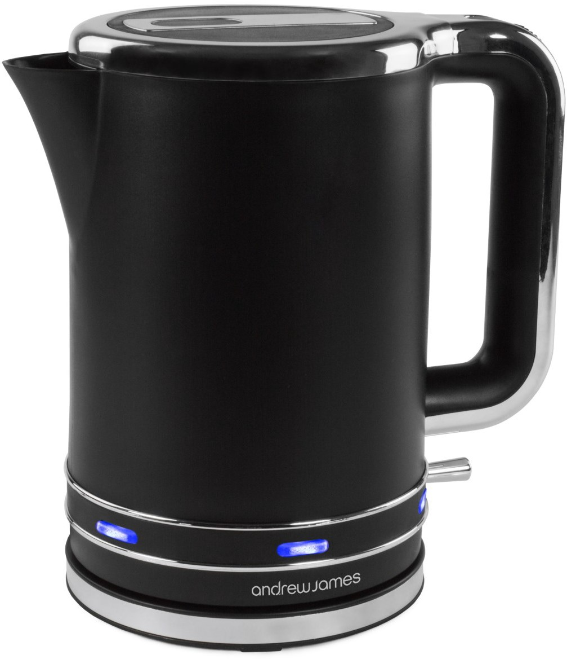

Please read the manual fully before using the appliance and keep the manual safe for future reference.

8

Safety guide

When using any electrical appliance, basic safety precautions should always be followed including:
- This appliance can be used by children aged from 8 years and above and persons with reduced physical, sensory or mental capabilities or lack of experience and knowledge if they have been given supervision or instruction concerning use of the appliance in a safe way and understand the hazards involved. Children shall not play with the appliance. Cleaning and user maintenance shall not be made by children unless they are older than 8 and supervised. Keep the appliance and its cord out of reach of children less than 8 years old.
- Always ensure the voltage on the rating label corresponds to the voltage in your home.
- Check the power cord and plug regularly for any damage. If the cord or the plug is damaged, it must be replaced by a qualified electrician or a service repair
centre. If in doubt please contact our customer service team.
- The appliance is intended for domestic use only. Industrial or commercial use
will void the warranty. The supplier cannot be held responsible for injury or
damage if the appliance has been used for anything other than its intended use.

- Incorrect operation and use can damage the appliance and cause injury to the user.
- Do not use the appliance if it has been dropped or damaged in any way. If the unit has been damaged take the unit for examination and or repair by an authorised service agent.
- Do not immerse or expose the motor assembly, plug or the power cord in water or any other liquid for any reason.
- If the supply cord is damaged, it must be replaced by the manufacturer or by someone who is suitably qualified to avoid a potential hazard.
- Do not let the cord hang over the edge of a table or counter. Ensure that the cord is not in a position where it can be pulled or tripped over accidentally.
- Do not allow the cord to touch hot surfaces and do not place the cord near hot gas, electric burners or in a heated oven.

Electrical information Please note:
It is extremely important that the wires or cores in the flex are connected to the correct terminals in the plug. If the colour of the mains lead of the appliance does not correspond with the coloured
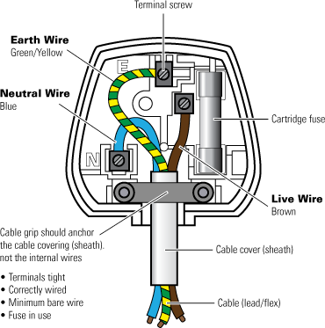
markings identifying the terminals in your plug proceed as follows:
- The Live (Brown) wire connects to the right- most live (L) terminal nearest to the fuse.
- The Neutral (Blue) wire connects to the left-most neutral (N) terminal.
- The Earth (Green and
Yellow) wire connects to
the central, top most
earthed (E) terminal.

Warning:

If the appliance is double insulated indicated by the double insulated symbol: it should not have an earth wire or earth connection.

Plug

The plug must be protected by the correct AMP fuse; this will be indicated on the case of the plug. Only BSI or ASTA approved fuses should be used. When changing the fuse always replace it with a fuse that is of the same identical rating as the original. If you
are unsure about which plug or fuse to use, always refer to a qualified electrician.

Please note after replacing the fuse, ensure that the cover is correctly fitted back onto the plug. Never attempt to run the appliance if the plug does not have a cover. If a moulded plug is fitted and has to be removed take great care in disposing of the plug and severed cable, it must be destroyed to prevent it from engaging into a socket. If the supply cord is damaged it must be replaced by a service agent or a similarly qualified person in order to avoid a hazard.

2 7

Removing mineral deposits

Periodically remove mineral deposits that collect in your kettle, this can be done by using commercial descaler or by following these basic instructions using white wine vinegar.
- Fill the kettle with 3 small cups of white wine vinegar, add water so that the kettle is full between the MIN/MAX mark.
- Once the kettle has boiled remove it from the heat. Pour out the cleaning mixture. Boil the kettle again with normal water and repeat several times until the odour of vinegar has disappeared.

Disposal of the appliance

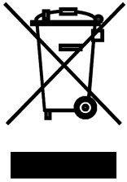
Please note that this Andrew James product is marked with this Symbol:

This means that this product must not be disposed of together with ordinary household waste, as electrical and electronic waste must be disposed of separately.
In accordance with the WEEE directive, every member state must ensure correct
collection, recovery, handling and recycling of electrical and electronic waste. Private households in the E.U. can take used equipment to special recycling stations free of charge. In certain member states used apparatus can be returned to the dealer where they were bought on the condition you buy new products. Contact your retailer, distributor or the municipal authorities for further information on what you should do with electrical and electronic waste.

  - Always remove the plug of the appliance safely. Do not pull on the appliances
cord to remove the appliance plug from the electrical socket.
  - Never handle or operate the appliance with wet hands.
  - Ensure that the kettle is used on a firm and flat surface out of the reach of children, this will prevent the kettle from overturning and prevent damage or injury.
  - Always take care to pour boiling water slowly and carefully without tipping the kettle too fast.
  - Be careful of refilling when the kettle is hot.
  - The attached base can not be used for anything other than its intended use.
  - Extreme caution must be used when moving an appliance containing hot water.
  - Unplug the kettle from the outlet when it is not in use and before cleaning.
Allow the kettle to cool before putting on or taking off parts and before cleaning the appliance.
  - The kettle can only be used with the stand provided.
  - If the kettle is overfilled, boiling water may spill our from the sides. Only fill to the recommended mark.

6 3

Appliance components illustration

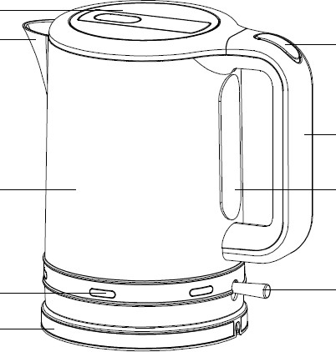
Lid Spout

Body

Indicator

Power base

Before first time use

Open lid button

Handle

Water gauge

Switch

Using the appliance

- Remove the kettle from the power base and open the lid by pressing the lid button.
- Place the kettle under a running tap and fill to above the minimum and below the maximum mark.
- Position the kettle on the power base.

- Connect the appliances plug to the electrical supply and switch the appliance on.

- Turn the kettles switch on. The light will indicate that the appliance is now on.

- Once the appliance has boiled the kettle will automatically flick off. You can cancel the boiling at any point by flipping the switch up.
- Lift the kettle from the power base and pour the water from the kettle.

Boil-dry protection

If you attempt or accidentally boil the kettle without water the boil-protection mechanism will automatically switch the appliance off.

Cleaning and maintenance
  - Disconnect the appliance before beginning cleaning.
  - Do not immerse the power cord or base of the appliance in water or liquid for

  - Clean the kettle before first time use by boiling a full kettle of water twice and then discarding the water. Wipe the surface with a damp cloth.

Please note: MAX capacity 1.7L
any reason.
  - Wipe the body of the appliance with a damp cloth or cleaner. Do not use
abrasive materials to clean the appliance.

  - Always unplug the appliance when it is not in use.

4 5

