University of Wolverhampton and TASS
Strength and Conditioning Studentship

MSc Strength and Conditioning – Equality, Diversity and Inclusion - Full Home Tuition Fee Bursary plus TASS CPD Package

Applicant Pack

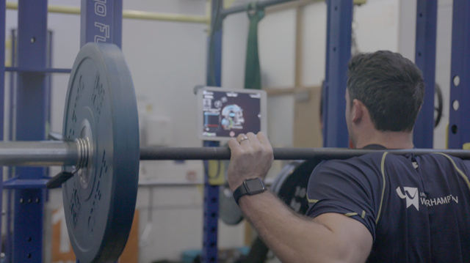
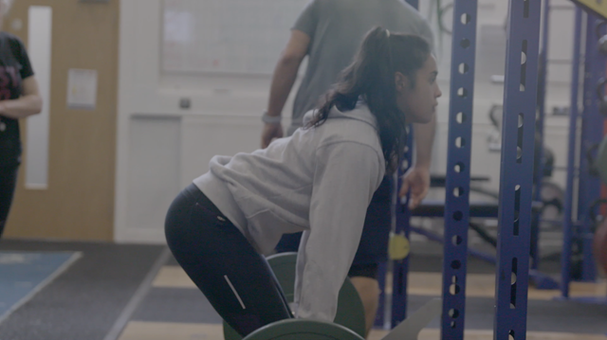

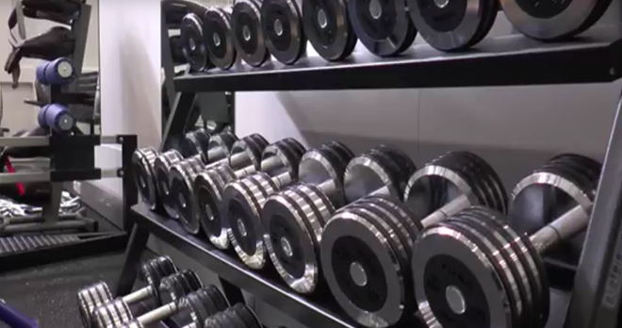
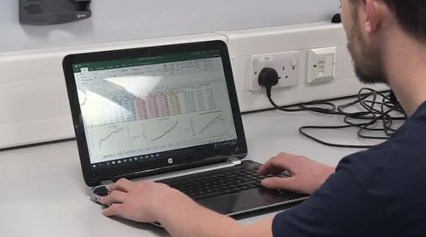

Overview
The University of Wolverhampton is working with TASS (Talented Athlete Scholarship Scheme) to welcome applications for our strength and conditioning bursary and CPD package. This studentship combines a bursary covering full home tuition fees for the MSc Strength and Conditioning and an additional bursary from TASS up to £2,500 to support with additional qualifications to enhance employment opportunities such as UKSCA accreditation. Alongside this, there will be an opportunity for the successful individual to work across a number of programmes and gain practical experience in coaching, sports science, working with professional bodies and lead elements of the WLV Sport strength and conditioning programme.
Aligning our work to Sport England’s broad ambitions to have a workforce within sport and physical activity which is representative of the population, TASS and the University are specifically recruiting for an individual from a diverse background for the bursary. More information can be found in the person specification of this document.
MSc Strength and Conditioning (full-time/part-time)
This exciting and applied course will develop scientific knowledge and skills for delivering strength and conditioning training methods within a range of contexts. The applied and practical nature of the course will equip students with the skills required to work with athletes and clients of different ages, abilities and demographics in designing and implementing bespoke training programmes to enhance athletic performance, health and wellbeing. For further information about the course please click here.
Strength and Conditioning Studentship
The strength and conditioning studentship provide a bursary covering all the successful applicants home tuition fees for the MSc Strength and Conditioning plus up to £2,500 in available funds towards CPD opportunities to enhance career and employment opportunities. In exchange, the successful applicant will support the WLV Sport strength and conditioning program by leading WLV BUCS Teams and WLV Sport Scholars as directed by the Lead Strength and Conditioning Coach. The successful applicant will be expected to complete up to 12 hours of coaching per week, inclusive of planning, delivery and professional development time. Throughout the strength and conditioning studentship, the successful applicant will:
- Receive mentoring from a UKSCA accredited coach.
- Undertake a comprehensive continuous professional development program.
- Gain hands on experience leading teams and individual athletes across multiple sports.
- Deliver within the British Judo National Training Centre that is housed on campus.
- Be able to claim up to £2,500 towards CPD and further employment opportunities.

Important Information
The full home tuition fee bursary and associated opportunity to coach within the WLV Sport strength and conditioning program is in combination with studying the MSc Strength and Conditioning. Therefore, successful progress on the MSc throughout the 2023-24 academic year is a requirement for continued receipt of the bursary and coaching opportunity offered.
The University of Wolverhampton welcomes applications for the strength and conditioning studentship from both home and international applicants. Please note that the full home tuition fee bursary will not cover all international fees. Any outstanding international tuition fees beyond those provided by the full home tuition fee bursary must be covered by the applicant.
Timeline
The studentship application deadline is 9:00 am on Monday 7th August 2023.
Interviews are expected to take place on the week commencing Monday 21st August 2023 in-person at the Walsall Campus Sport Centre.

Role Description and Person Specification
Role title: | Strength and Conditioning Studentship
Organisation providing bursary: | University of Wolverhampton
Department: | WLV Sport
Working hours: | 12 hours per week (September to April)
Fee: | Bursary covering full home tuition fees for study of the MSc Strength and Conditioning (full time/part time) plus up to £2,500 additional funds available for CPD and career development opportunities.
Report to: | Lead Strength and Conditioning Coach

Role Description:
1. Plan and deliver on-field/court warmups, speed training and conditioning, as well as gym-based resistance training and injury prevention sessions, to individual and team sport student athletes.
2. Lead fitness testing sessions for student athletes and create appropriate feedback reports to disseminate results to athletes and coaches.
3. Engage in CPD activities, mentor meetings and related administration.
4. Maintain the performance gym to high standards of cleanliness.
5. Support strength and conditioning related outreach activities and initiatives.

Person Specification | Criteria | Example evidence required if shortlisted for interview*
Qualifications | 1. Undergraduate degree at 2:2 or above in sport science, strength and conditioning or a related discipline (E).  2. Relevant gym instructor, personal trainer or strength and conditioning certification (E).  3. Sports coaching qualification from a recognised national governing body (D).  4. Associate membership of the UKSCA (D). | Academic transcript.  Certificates.  Verification of professional body membership.
Experience | 1. Experience leading groups and individuals through exercise sessions (E).  2. Experience delivering strength and conditioning to individuals or groups (D).  3. Experience running fitness testing sessions and creating feedback reports (D). | Suitable employment reference.
Personal qualities | 1. A desire to follow a career within the field of strength and conditioning (E).  2. Excellent organisational and problem-solving skills (E).  3. The ability to work independently and as part of a team (E).  4. A keen interest in research and applied practice within strength and conditioning (D). | Suitable personal reference.
Additional Pre-Conditions | This scholarship has been created to address the current gaps in diversity representation amongst sport practitioners in the UK talent pathway as well as in higher education. As such, this scholarship aims to intentionally include an individual who is from a culturally diverse background or an individual with a disability.
*Please note all evidence will be checked for applicants who are shortlisted for interview.
In addition, the successful applicant will need to complete a DBS check prior to commencing the MSc Strength and Conditioning.

How do I Apply?
The application is a two stage process. You must submit BOTH stage 1 and stage 2 applications before the deadline.
Stage 1: Apply for the MSc Strength and Conditioning
If you have any questions about the course, please email c.blades@wlv.ac.uk they will answer your query or put you in touch with the course leader who will be happy to assist.
To apply for the MSc Strength and Conditioning complete the online application form as well as upload a suitable reference and other relevant supporting information, such as your degree certificate. Please note that the personal statement section of the application form is a key element of the decision process in determining your suitability for the course, so it is imperative you read the information about how to write your personal statement below.
Please visit the MSc Strength and Conditioning course page and click on ‘Apply now’.

HOW TO WRITE YOUR PERSONAL STATEMENT
Your personal statement is a substantial and important part of your application that will be used to determine your eligibility for the course and may distinguish you from other applicants. Your personal statement is read thoroughly by the admissions unit and admissions tutors when your application is being considered.

What makes a good personal statement?

Explain your reason for applying for the MSc Strength and Conditioning: You should focus your personal statement to the MSc, and it should support your desire to study the course. You should explain your reasons for applying for the course – why would this course suit you? What interests you about the course? You should demonstrate enthusiasm and commitment to the course, to undertaking research in your chosen field and to pursuing a career in S&C.

Generic Information for all Personal Statements

Clear and well written: Your Personal Statement should be clear, well written, well-structured and display good English language skills. It should be organised into paragraphs with an introduction, middle and end.

Highlight what you have done to develop knowledge of your chosen area of study: You should detail any jobs, placements, work experience (paid or unpaid) or activities (which could include previous study) that you have undertaken to develop your interest/knowledge in the area that you have chosen to study. This should include the nature of the experience/activities, where you worked/studied and the amount of time you spent there. You should also state when this experience took place.
When considering the course you are applying to it is important that you identify the personal qualities you possess or have developed, that will contribute to and help you during the course. You should ensure that you identify your personal qualities and transferable skills within your Personal Statement. You should show you have a general knowledge and insight about the subject area you will be studying. How will your present knowledge help you?

Show you have carefully considered your study choice: We would be interested to know how the course relates to your future plans.

Overseas applicants: If you are applying from overseas, your personal statement should also explain your reasons for choosing to study in the UK and why you chose the University of Wolverhampton. Addressing these areas in your personal statement will help you to develop your answers to the questions that you may be asked as part of your visa application interview.

Previous study in the UK: If you have previously studied in the UK and you are applying to study a course at the same or a lower level than your previous course, your personal statement must clearly outline why you wish to study your course and how it will relate and add to your previous qualification from your previous course.
If you will require sponsorship for a Tier 4 Student Visa and the University is not satisfied that your course of study demonstrates satisfactory academic progression we may not be able to proceed with your application.

Changes to personal statements: Once you have submitted your personal statement we will not accept amended versions.

Similarity detection: Your personal statement should be your own work and individual to you. All personal statements are read thoroughly by the Admissions Unit and if similarities are spotted between your personal statement and those from other applicants, your application may be refused.
Stage 2: Apply for the Strength and Conditioning Studentship
Once you have submitted your application for the MSc Strength and Conditioning, you may then apply for the strength and conditioning studentship. Please e-mail a copy of your CV (max two pages of A4) and a cover letter (max one page of A4) explaining why you think you are suitable for the studentship to the following email address: c.blades@wlv.ac.uk. Please clearly name your email subject and cover letter title as “UoW Strength and Conditioning Studentship Application”.
You must submit your application for the strength and conditioning studentship prior to the closing date of 9:00 am on Monday 7th August 2023. Applicants subsequently provided with an offer to study the MSc Strength and Conditioning will be put forward for shortlisting for the bursary position. You do not have to wait for your course application to be processed before submitting your application for the studentship.
What happens following my application?
Your application for the MSc Strength and Conditioning will be processed and you will be informed via our admissions department whether you have been offered a place on the course.
Applicants who have been offered a place on the MSc Strength and Conditioning will then have their studentship application put forward for shortlisting. A shortlist will subsequently be drawn up and those applicants will be invited for interview.
Interviews for the studentship are expected to take place on the week commencing Monday 21st August 2023 in-person at the Walsall Campus Sport Centre. The interviews will include a practical assessment, as well as questions from the interview panel.
For further information about the MSc Strength and Conditioning, or for an informal discussion about the studentship, please contact the admissions department: Tel 01902 322222, E-mail WlvEnquiries@wlv.ac.uk

