The University of Wolverhampton in partnership with University Hospitals Coventry and Warwickshire NHS Trust

PhD Studentship: Developing a bespoke lifestyle intervention to support women living with polycystic ovary syndrome (PCOS)

Applicant Pack
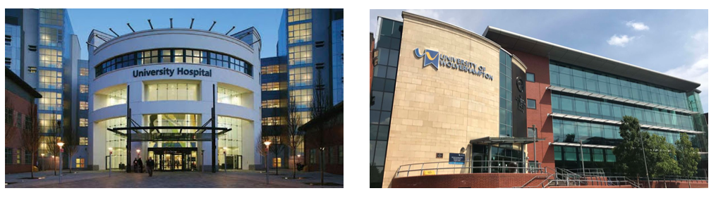

University of Wolverhampton

PhD Studentship

The School of Health and Society are offering a funded PhD studentship opportunity in conjunction with the Warwickshire Institute for the Study of Diabetes, Endocrinology, and Metabolism (WISDEM) at the UHCW NHS Trust. We are offering a £15,000 per annum stipend (3 years) plus tuition fees for applicants interested in studying a PhD at the University of Wolverhampton.

Closing Date: Friday 4th August 2023

Interview Date: Week commencing 14th August 2023 TBC

To apply for this studentship, please send a CV and an expression of interest (of no more than 500 words) outlining your suitability for the role. Please send these as attachments via email to FEHWacademicsupport@wlv.ac.uk. Please include UHCW Studentship in the subject line and mark them for the attention of Dr Chris Kite.

Role Descriptor
Polycystic ovary syndrome (PCOS) is the most common endocrine disorder in reproductive-aged women which affects up to 20% of this female population. Whilst PCOS is typically diagnosed based on the presence of at least two out of three criteria (i.e. chronic anovulation, hyperandrogenism, and polycystic ovaries), individuals with PCOS are also at an increased risk of cardiometabolic complications (e.g., obesity, insulin resistance, type 2 diabetes, and hypertension) and psychological morbidity (e.g., depression, anxiety, and reduced self-esteem) which results in impairments to quality of life. As there is currently no curative treatment, management of PCOS aims to alleviate the clinical manifestations, whilst lowering the related risk of cardiometabolic and psychological morbidity. Accordingly, first line management recommendations focus on lifestyle changes aiming to increase physical activity and improve dietary habits.

Whilst our previous research and ongoing research collaboration with UHCW NHS Trust have revealed beneficial effects on a range of health-related outcomes following physical activity interventions, we are also aware that there is a lack of well-designed, clearly reported studies to increase our confidence in these findings. This has prompted our research group to prioritise our understanding of the health determinants of individuals with PCOS, and to develop appropriate lifestyle interventions to improve it.
Funding is available to support a full-time funded (£15,000 per annum + fee waiver) PhD, over a three-year period from September 2023 (or as soon afterwards as possible). If required for write-up, there is an optional fourth year which would be self-funded. This PhD studentship is the next step in an ongoing project between the University of Wolverhampton and the UHCW NHS Trust which aims to develop a lifestyle intervention for increasing physical activity in women with PCOS. The intervention content and delivery methods will be determined using co-production techniques in order to improve relevance and acceptability of the intervention within the target population. This project builds upon prior research work by our team which has identified the potential of such interventions for improving the health of individuals living with PCOS, and these will be incorporated into the intervention.

The PhD student will usually be located at the University of Wolverhampton (City Campus) but will also be expected to attend the WISDEM Centre (at UHCW NHS Trust, Coventry) during data collection periods, or to undertake duties at the hospital which are complementary to the PhD research (agreed in advance with the supervisory team). Time will be provided for associated tuition, general research training and mandatory attendance at the Annual Progress Review. Whilst the successful applicant may undertake duties at the hospital, the focus and primary aim shall remain the successful completion of the PhD in the allotted timeframe.

Applications are invited from ambitious, self-motivated, and enthusiastic candidates to work on a funded PhD studentship. Funding and stipend are provided by The University of Wolverhampton and the UHCW NHS Trust to develop a lifestyle intervention to support individuals living with PCOS in the management of their condition. It is anticipated that the project will utilise a range of relevant research methodologies related to physical and mental health and wellbeing. The precise research question(s) and methodologies adopted will be negotiated with the successful applicant.

Due to funding restrictions, this studentship is only open to UK/EU applicants.

Person Specification
ATTRIBUTE | ESSENTIAL | DESIRABLE
Education/  Qualifications | - Applicants should hold an undergraduate (1st or 2:1) honours degree (or equivalent) in a relevant subject | - A UK masters-level qualification in a related area (e.g., exercise science, psychology, public health)
Specific Skills/  Experience | - Good understanding of qualitative and quantitative research methods and designs | - Evidence of managing research projects.  - Experience of working with clients/patients in health promotion or exercise settings.
Research/Publications Special Interests | - Evidence of published conference or journal papers relating to the topic or willingness to do so.  - Up to date knowledge and understanding of relevant discipline and commitment to continued professional development. | - Experience of giving conference presentations and/or publishing research papers.
Job related skills/aptitudes. | - Excellent communicator (written and verbal) with an organised approach to work.  - Confident to work independently and as part of a team.  - Self-motivated and able to take initiative, and to work both unsupervised and to close direction.  - Must be a team player and able to work towards a common research goal. | - Flexible approach to work; adaptable depending upon demands.
Other requirements | - Commitment to the University’s policy framework on diversity and inclusivity and the University’s policies on health and safety.  - May be required to work outside of normal working hours (8.30am to 5:00pm) including weekends, on occasion.  - Willingness to travel to other organisations nationally and internationally.  - Able to take responsibility for developing their own career in partnership with the University.

