University Library: Skills for Researchers

Guide to Systematic Review

Introduction

This guide provides an introduction to the issues that need to be considered when undertaking a comprehensive literature search for a systematic review.

What is a Systematic Review?

Systematic reviews are a type of research that attempts to find primary research using explicit methods to help answer a specific question. Though first developed within the field of medicine they are also increasingly being produced within social sciences. Due to their complexity a systematic review can take up to a year to produce from the formation of the initial review team to the publication of the systematic review. A definition of a systematic review in medicine is given below:
“A summary of the medical literature that uses explicit methods to perform a comprehensive literature search and critical appraisal of individual studies and that uses appropriate statistical techniques to combine these valid studies” (Centre for Evidence Based Medicine).
The key features of a systematic review are:
• A clearly defined question.
• Explicit research methods (including a clear search strategy and inclusion and exclusion criteria for studies to reduce bias).
• A systematic search that attempts to identify all studies that would meet the eligibility criteria.
• An assessment of the validity of the findings of the included studies, for example through the assessment of risk of bias.
• A systematic presentation, and synthesis, of the characteristics and findings of the included studies, which includes the search methodology.
• Depending on the topic it may contain a meta-analysis – a statistical technique that summarizes the results of several studies in a single weighted estimate, in which more weight is given to results of studies with more events and, sometimes, to studies of higher quality.

How is a systematic review different to a literature review?

The terms literature review and systematic review are often used inter-changeably, which can cause confusion. While both aim to summarise the available literature on a topic, a literature review may have a more general topic or question, provide only a basic account of the inclusion/exclusion criteria used and select articles for inclusion on a qualitative or subjective basis in order to provide an overview of the topic. This is especially true of a ‘narrative’ style of literature review, which tends towards a descriptive rather than scientific approach. However, a literature review can use a ‘systematic’ approach (making use of features used in systematic reviews) in order to make the process more rigorous, whilst still not being considered a full ‘systematic review’ in the strictest sense.

Where do I find Systematic Reviews?

The Cochrane Library produces systematic reviews and is considered the ‘gold standard’. You can search their website (see Further Reading) and find other examples by limiting your search to systematic reviews in bibliographic databases such as Medline and CINAHL.

How does producing a systematic review impact on how I search for and manage my search results?

You will need to develop a review protocol where you outline the proposed approach to the systematic review and a draft search strategy. When searching for literature for a systematic review you will need to conduct comprehensive advanced searches across several databases, save your results and search strategies, record the date of searches and number of citations retrieved. There are several stages when searching and managing your results, which include:
• Develop the Review Protocol
• Search for Studies
• Report the Search
You can find examples of review protocols on PROSPERO (see Further Reading).

Develop the review protocol

The review protocol is used to outline the proposed approach to the systematic review; it gives background to the topic and seeks to highlight the questions that the systematic review will address. The review protocol can include:
• Study Question & Methods
• Searching
• Screening
• Data extraction and management

Searching for Studies

Once you have developed your review protocol you will need to carry out searches to find studies/literature. You will need to use a variety of methods to identify the literature for your systematic review, as shown in the following table:
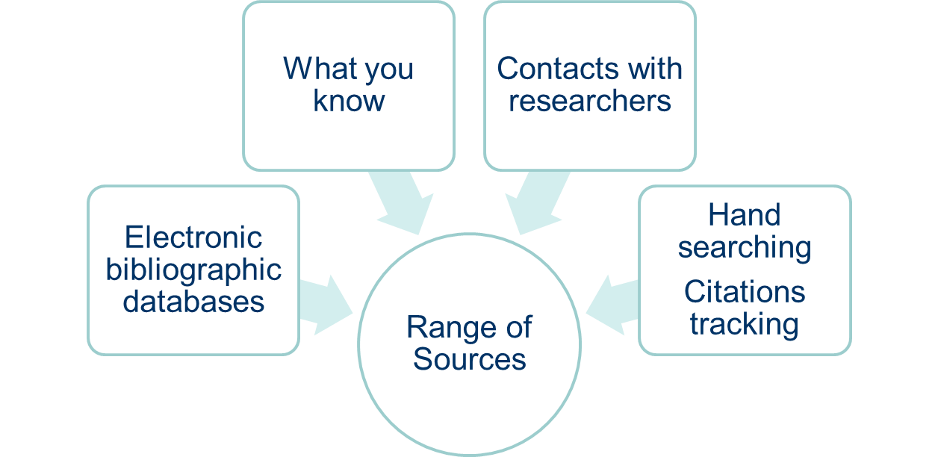
Greenhalgh, T. and Peacock, R. (2005) Effectiveness and efficiency of search methods in systematic reviews of complex evidence: audit of primary sources, BMJ, 331(7524), pp.1064-5.
The Guides to Systematic Reviews listed in Further Reading provide more detail on searching for studies/literature. The guides recommend searching at least two bibliographic databases, as well as considering citation tracking and scanning key journals in the relevant field (hand searching).

Reporting the Search

The PRISMA statement (see Further Reading) is increasingly becoming the preferred reporting method of systematic reviews. You will need to ensure your search strategies provide enough detail to be reproducible and transparent. List all sources searched and include the search strategy for at least one database and the time periods of the search. You will also need to manage your citations. All of the citations you retrieve from your database searching will need to be exported into a citation management system, such as RefWorks. At the end of your searching, a process of deduplication will need to be carried out. If you are using RefWorks as your citation management system you will need to create a number of different folders and be familiar with the advanced features of RefWorks.

Before you begin a systematic review you will need to ask:

• Has anyone done a systematic review on this question before? If so, how long ago was the systematic review conducted? Was the systematic review well-conducted?
• Is a systematic review required? Are there enough studies in the area to produce a systematic review on my topic?
• Have I identified all of the relevant databases and additional sources I need to search? Am I familiar with these databases and do I have an understanding of their advanced search and account features?
• Am I up to date with advanced search techniques, such as search filters, proximity searching and wildcards?
• Am I confident with the advanced features of the citation management system I am using?

How the Library can help:

We can support you with your systematic review by:
• Providing advice on developing your review protocol by helping you to identify relevant databases and resources.
• Advise you on appropriate search terms and advanced searching techniques.
• Provide subject database training covering the advanced features of a database.
• Provide support for RefWorks, with guides, workshops and one-to-one help.

Further Reading

Finding Systematic Reviews

The Cochrane Library - Part of the Cochrane Collaboration, a research network that produces systematic reviews on a range of health/medical topics. Cochrane Systematic Reviews are updated according to need. www.cochranelibrary.com
The Campbell Collaboration - Research network that produces systematic reviews in the social sciences including: education, crime and justice, international development and social welfare. www.campbellcollaboration.org

Review Protocols

PROSPERO - an international database of prospectively registered systematic reviews in health and social care. Only includes interventions within healthcare. Researchers can register their systematic review title. www.crd.york.ac.uk/prospero

Guides to Systematic Reviews

Centre for Reviews and Dissemination Guidance for Undertaking Reviews in Healthcare - guide developed by the CRD; a detailed handbook on producing a systematic review, including advice about identifying sources and examples of how to report your search.
www.york.ac.uk/crd/guidance
Guidelines for Guidelines: Develop - from the Australian National Health and Medical Research Council. Includes forming the questions, identifying the evidence and synthesising evidence.
www.nhmrc.gov.au/guidelinesforguidelines/develop
Cochrane Handbook for Systematic Reviews of Interventions - An in-depth guide to producing a systematic review https://training.cochrane.org/handbook/current

Reporting the Systematic Review Search

PRISMA - Preferred Reporting of Systematic Reviews and Meta Analyse www.prisma-statement.org

Help and Advice

If you would like further help, please use our Library ASSIST chat https://wlv.libanswers.com or email the Liaison Librarian team at LISliaison@wlv.ac.uk

To request this document in an alternative format please contact LISliaison@wlv.ac.uk

